About Maven for MS2

Maven File system:  
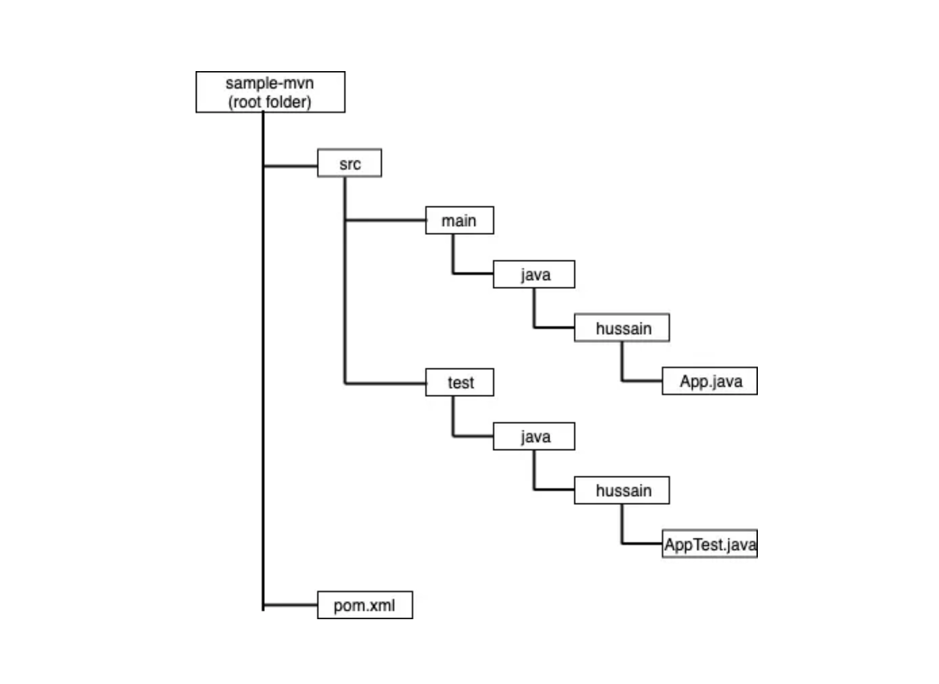

**Maven build lifecycle**

Maven build lifecycle is a set of phases that is executed when a maven build is run. There are three build lifecycles: default, clean, and site. The default lifecycle comprises of the following phases:

* **validate** — validate the project is correct and all necessary information is available
* **compile** — compile the source code of the project
* **test** — test the compiled source code using a suitable unit testing framework. These tests should not require the code to be packaged or deployed
* **package** — take the compiled code and package it in its distributable format, such as a JAR.
* **verify** — run any checks on results of integration tests to ensure quality criteria are met
* **install** — install the package into the local repository, for use as a dependency in other projects locally
* **deploy** — done in the build environment, copies the final package to the remote repository for sharing with other developers and projects.

These lifecycle phases are executed sequentially to complete the default lifecycle.